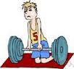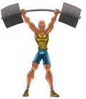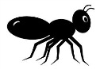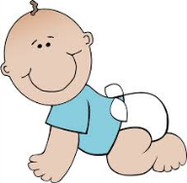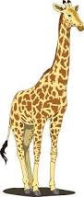[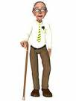](http://www.google.com.au/imgres?imgurl=http://sr.photos2.fotosearch.com/bthumb/CSP/CSP229/k2295498.jpg&imgrefurl=http://www.fotosearch.com/clip-art/grandpa.html&h=170&w=128&tbnid=ztx3PyQRvxcj5M:&zoom=1&q=grandpa%20clip%20art&docid=7EgYplgM3dxwPM&ei=nuOoU4qrBMe7kQWWsoGYAQ&tbm=isch&ved=0CE8QMygqMCo&iact=rc&uact=3&dur=1441&page=4&start=38&ndsp=13)

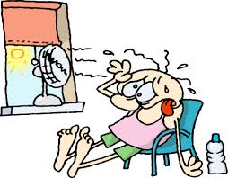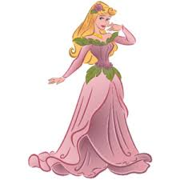

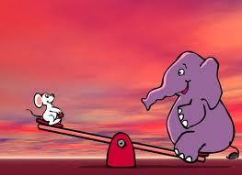

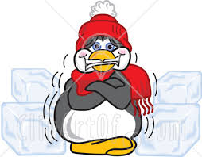

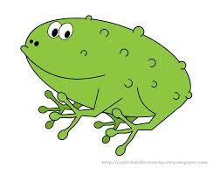

Draw 2

Draw 4

Change colour

[](http://www.google.com.au/imgres?imgurl=http://sr.photos2.fotosearch.com/bthumb/CSP/CSP229/k2295498.jpg&imgrefurl=http://www.fotosearch.com/clip-art/grandpa.html&h=170&w=128&tbnid=ztx3PyQRvxcj5M:&zoom=1&q=grandpa%20clip%20art&docid=7EgYplgM3dxwPM&ei=nuOoU4qrBMe7kQWWsoGYAQ&tbm=isch&ved=0CE8QMygqMCo&iact=rc&uact=3&dur=1441&page=4&start=38&ndsp=13)











Draw 2

Draw 4

Change colour

[](http://www.google.com.au/imgres?imgurl=http://sr.photos2.fotosearch.com/bthumb/CSP/CSP229/k2295498.jpg&imgrefurl=http://www.fotosearch.com/clip-art/grandpa.html&h=170&w=128&tbnid=ztx3PyQRvxcj5M:&zoom=1&q=grandpa%20clip%20art&docid=7EgYplgM3dxwPM&ei=nuOoU4qrBMe7kQWWsoGYAQ&tbm=isch&ved=0CE8QMygqMCo&iact=rc&uact=3&dur=1441&page=4&start=38&ndsp=13)











Draw 2

Draw 4

Change colour

[](http://www.google.com.au/imgres?imgurl=http://sr.photos2.fotosearch.com/bthumb/CSP/CSP229/k2295498.jpg&imgrefurl=http://www.fotosearch.com/clip-art/grandpa.html&h=170&w=128&tbnid=ztx3PyQRvxcj5M:&zoom=1&q=grandpa%20clip%20art&docid=7EgYplgM3dxwPM&ei=nuOoU4qrBMe7kQWWsoGYAQ&tbm=isch&ved=0CE8QMygqMCo&iact=rc&uact=3&dur=1441&page=4&start=38&ndsp=13)

Draw 2

Draw 4

Change colour











Reverse

Skip

Reverse

Reverse

Reverse

Skip

Skip

Skip

Reverse

[](http://www.google.com.au/imgres?imgurl=http%3A%2F%2Fsr.photos2.fotosearch.com%2Fbthumb%2FCSP%2FCSP229%2Fk2295498.jpg&imgrefurl=http%3A%2F%2Fwww.fotosearch.com%2Fclip-art%2Fgrandpa.html&h=170&w=128&tbnid=ztx3PyQRvxcj5M%3A&zoom=1&q=grandpa%20clip%20art&docid=7EgYplgM3dxwPM&ei=nuOoU4qrBMe7kQWWsoGYAQ&tbm=isch&ved=0CE8QMygqMCo&iact=rc&uact=3&dur=1441&page=4&start=38&ndsp=13)



Change colour

Draw 2

Draw 4

Skip