Making Connections

Good readers make personal connections to
what they read. It helps us to understand
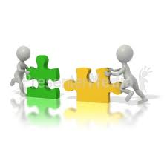
what we are reading.

Discussion Starters
*This reminds me of…
*This made me think of…
*I read another book that…
*Something like this happened to me once…
*This character has a similar problem to...
*This is different from…
*This is similar to…
*This reminds me of a TV/movie…
*This is different from my life because...
*This is the same as my life because…
*This character reminds me of…
*Things I have in common with the character…
*Things I have different to the character are…

Predicting

Good readers use information from pictures,
text, and pictures to predict what will be
read, viewed and heard, They actively adjust
understanding while reading, viewing and
listening.

Discussion Starters (1)
*What do I think will happen next? I think…
*What do I expect to happen next? I expect…
*What words do I expect to see next?
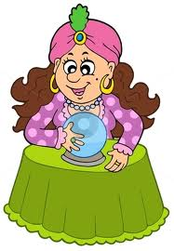
I expect to see…

*What pictures might I see?

Discussion Starters (2)
*How will I confirm my predictions? I will
confirm my prediction by…

*What helped me make my prediction?... helped
me make my prediction.

*Why do I think that? I think that because…

*My prediction was right/wrong because…

Visualising

Good readers create a visual image from the
text they read. Visualising brings the text to
life and activates your imagination.

Think???
*Do I have a picture in my mind as I am
reading?

*Can I describe the picture in my head and
relate it to the paragraph I am reading?

Discussion Starters
*I can sketch the picture in my head (draw a
quick sketch to show what you understand about
the paragraph).

*In my head I can see…

*I can imagine what it must be like to…

*The picture of ….. in my mind helped me
to understand ….

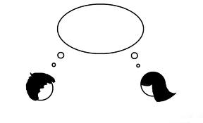
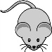
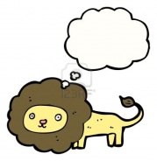

Summarising

Good readers identify and gather the most
important ideas and restate them in their own
words.

Think???
*What were the main points of the
paragraph?

*What would help me summarise this text?
e.g Mindmap, brainstorm,
highlighting words, notes

Discussion Starters
*If I had to tell another person about what I
I read/viewed I would say…

*What is the main theme? The main theme
is ….

*What words would I highlight to help me
understand the passage? I would highlight….

*How is this connected to the real world?
It is connected to the real world because …

*Who are the main characters in the text?
The main characters are ….
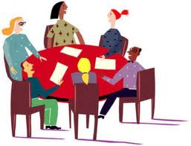

Questioning

Good readers create and answer questions that
make clear the meaning and give us a deeper
understanding of what we are reading.

Discussion Starters
*What was my favourite part? My favourite
part was ….

*Which character was the most interesting?
I think …..

*How did (add character name) feel and
why? (add character’s name) felt…..
because…..

*Do you agree or disagree with the choices a
character made in the story? Why?

*If I was the author, which part of the story
would I be most proud of? I would be most
proud of ….

*Whose point of view was the story told
from? How do you know this?

*Why did the main event in the text happen?
The main event happened because …
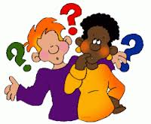

Monitoring

Good readers stop and think about the text
and know what to do when meaning is
disrupted.

Discussion starters
*What have I learned from this text?
I have learned …..

*What words were you unsure of? What
words didn’t make sense? What words
were new words?

*Were there any parts where you didn’t
know what the author meant?

*What did you use to help you understand an
unknown word or the meaning of a sentence
that didn’t make sense?

*What tips do you have for others to help
them make sense of this story?

