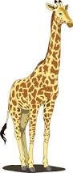

oi

ea

ee

ow

ou

oy

Draw 2

Draw 4

Change colour

ee

ou

ea

oy

oi

ow

Draw 2

Draw 4

Change colour

ea

ow

ee

oy

oi

ou

Draw 2

Draw 4

Change colour

Draw 2

Draw 4

Change colour

oy

oi

ow

ee

ea

ou

Reverse

Skip

Reverse

Reverse

Reverse

Skip

Skip

Skip

Reverse

ou

ea

ee

ow

Change colour

oy

oi

Draw 2

Draw 4

Skip