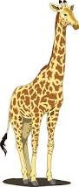

wh

ch

sh

er

ar

th

Draw 2

Draw 4

Change colour

sh

wh

ch

er

ar

th

Draw 2

Draw 4

Change colour

ch

th

sh

wh

ar

er

Draw 2

Draw 4

Change colour

Draw 2

Draw 4

Change colour

ar

er

th

sh

ch

wh

Reverse

Skip

Reverse

Reverse

Reverse

Skip

Skip

Skip

Reverse

wh

ch

sh

th

Change colour

ar

er

Draw 2

Draw 4

Skip