Reading Worksheet

I wonder… I wonder ___________________
________________________________
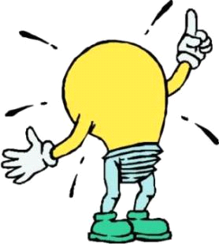 I remember ____________________
________________________________________
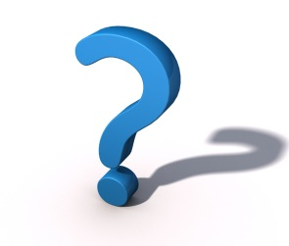Words I was unsure of ____________
________________________________________
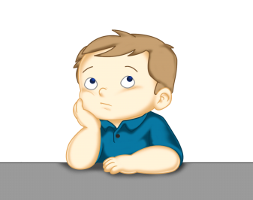 Something I didn’t already know ________________________________________
________________________________________

