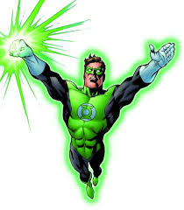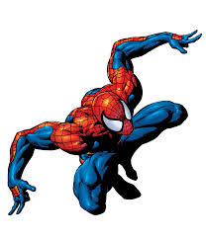

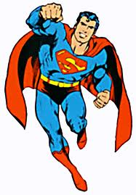

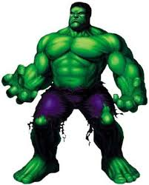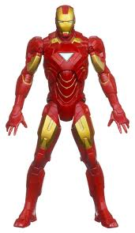

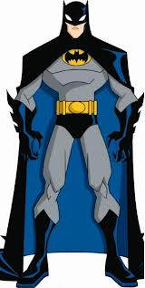

Draw 2

Draw 4

Change colour







Draw 2

Draw 4

Change colour







Draw 2

Draw 4

Change colour



Draw 2

Draw 4

Change colour





Reverse

Skip

Reverse

Reverse

Reverse

Skip

Skip

Skip

Reverse

Skip



Draw 4

Draw 2

Change colour