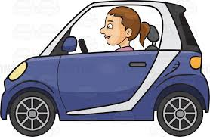





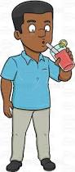

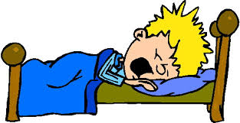

Draw 2

Draw 4

Change colour











Draw 2

Draw 4

Change colour











Draw 2

Draw 4

Change colour

Draw 2

Draw 4

Change colour











Reverse

Skip

Reverse

Reverse

Reverse

Skip

Skip

Skip

Reverse



Change colour

Draw 2

Draw 4

Skip