





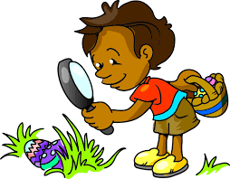



Draw 2

Draw 4

Change colour











Draw 2

Draw 4

Change colour







Draw 2

Draw 4

Change colour



Draw 2

Draw 4

Change colour



Reverse

Skip

Reverse

Reverse

Reverse

Skip

Skip

Skip

Reverse





Change colour

Draw 2

Draw 4

Skip